Verify+ New Feature List

3.2.0
- Added support to view letters from the Independent Test Lab (ITL).
- Added Novomatic CFAST to Directory options so manual copying of the media is no longer required.
- Added color coding for when a signature is the result of no data being read.
- Added database matching and color coding when using the Import feature.
- Added Import feature to Tools menu so it can be used when the verification grid is empty.
- Improved Import functionality to accommodate import files that do not have the same algorithms as currently selected.
- Updated USB version to successfully run when the user does not have administrator permissions.
- Updated USB key handling to reduce errors on startup.
- Improved update logic to reduce vague error messages.
- Allow odd number of characters for text HMAC NGI verification.
- Language Support
  - In the Options menu, the user can choose to use Verify+ in a different language.
  - Currently, these languages are supported:
    - English
    - Spanish
    - French
    - German
    - Japanese
    - Dutch
    - Italian
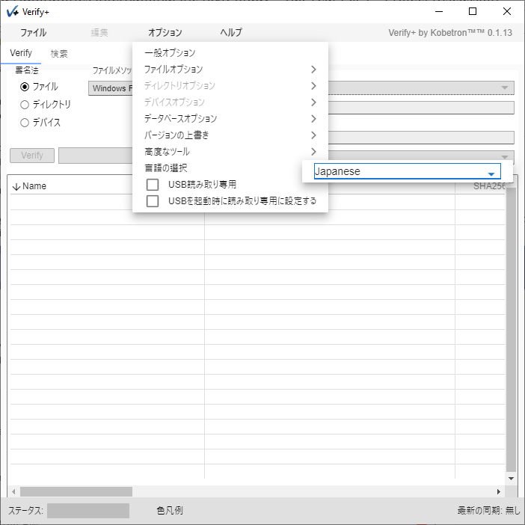

- Run as Administrator Option
  - Allows a system administrator to enter in user credentials of an administrator account that Verify+ will run as on the next start up.
  - This can be very useful for organizations that do not want to grant users of Verify+ administrator permissions.

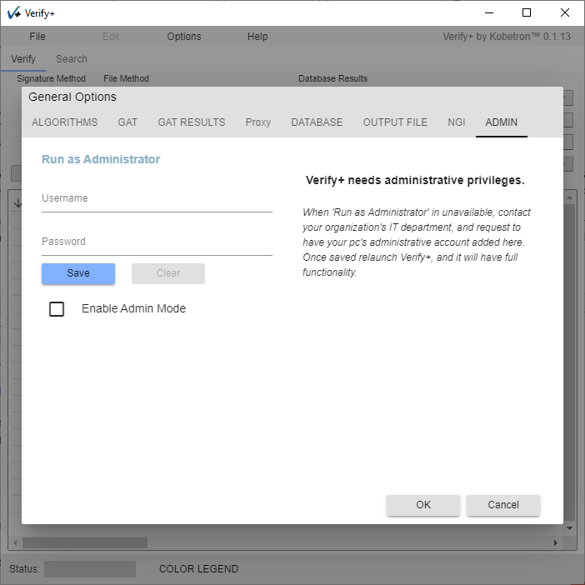

- Upload Calculated Signatures (GLI)
  - If the user is on the GLI domain, they will have the option to upload a selected row of signatures to the Submissions Database
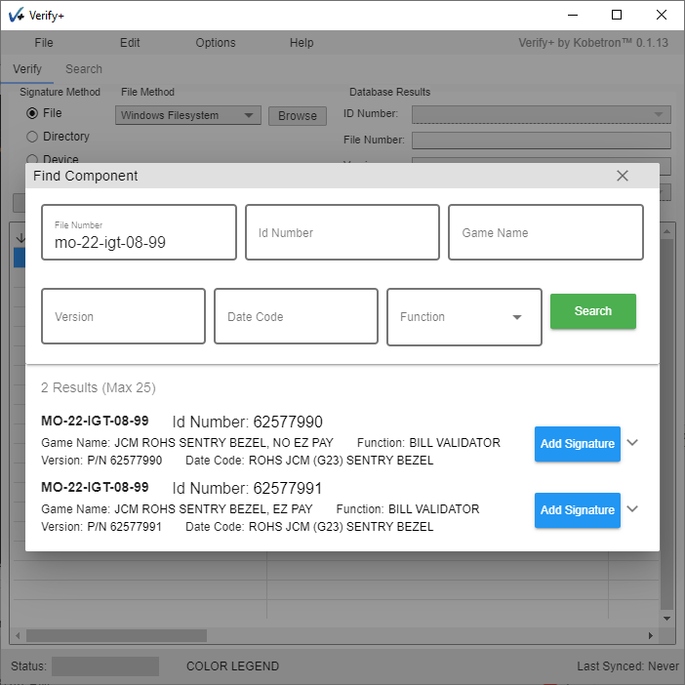

- Upload Calculated Signatures (IRIS)
  - Users have the option to upload signatures to IRIS.
  - The user is first presented with a login prompt

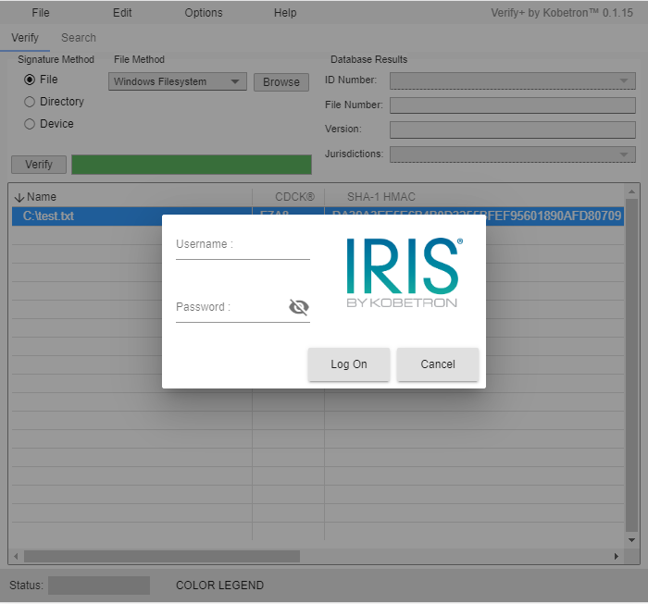

  - Then the user can choose a property, EGM, and component to associate the signature(s) to.
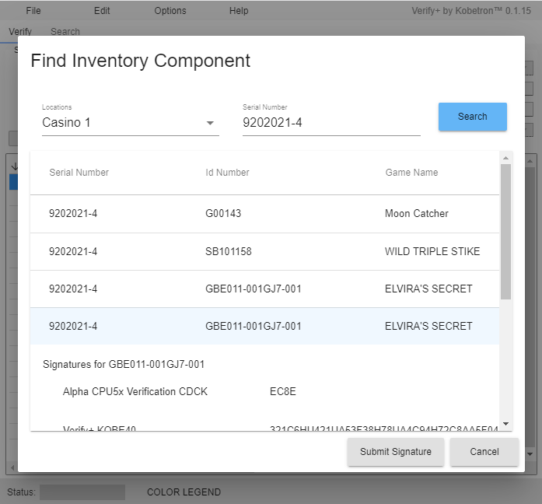

- Show XOR Signatures
  - If the user selects multiple rows of generated signatures, then the Show XOR Signatures option can be used from the Edit or right-click context menus.
  - This feature XORs the Hex-based algorithms of the selected rows together into a single signature.
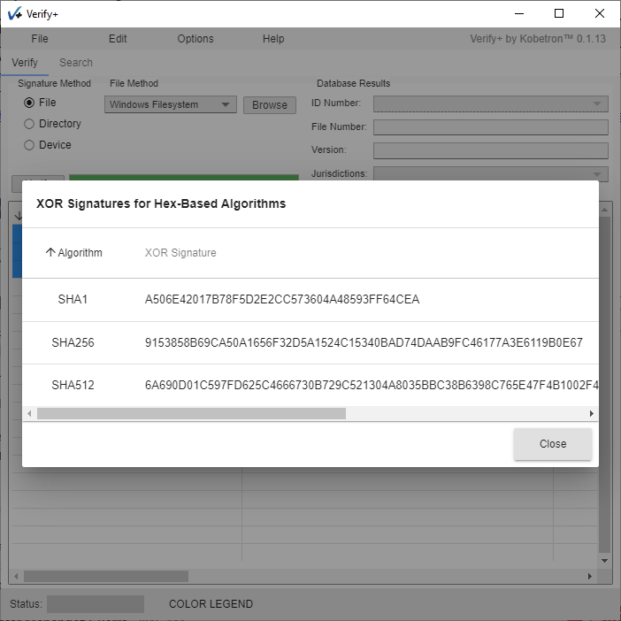

- Added Output file size option
  - An option has been added to the output file to include the device size for the signatured item(s).

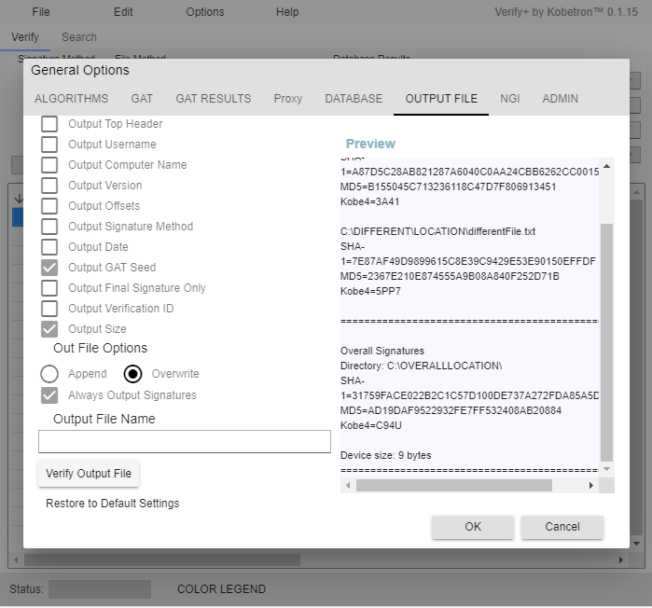

- Added signature text feature
  - An option was added to the Tools menu for Text Signature Tool. This allows the user to type or paste in text and then use the Verify button to generate signatures for all of the enabled algorithms.
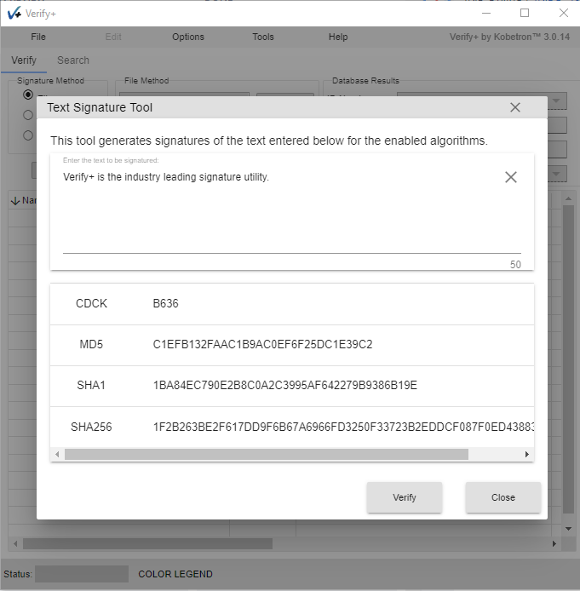

- Added NGI URL Manager
  - When verifying components through NGI, many different URLs could be used by the user to query. The NGI URL Manager allows the user to store NGI Server URLs so they can be easily selected in the future. The "Manage URLs" button is used to bring up the interface to add, edit, or remove stored URLs.
