Verify+ 3.0 Feature List

- Windows 11 Support

- License warranty expiration countdown and Promotional license countdown

- Release notes available
  - In the help menu, you can now see the release notes from previous versions.
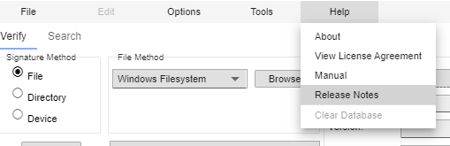

- Language Support
  - In the Options menu, the user can choose to use Verify+ in a different language.
  - Currently, these languages are supported:
    - English, Spanish, French, German, Japanese, Dutch, Italian

- Run as Administrator Option
  - Allows a system administrator to enter in user credentials of an administrator account that Verify+ will run as on the next start up.
  - This can be very useful for organizations that do not want to grant users of Verify+ administrator permissions.
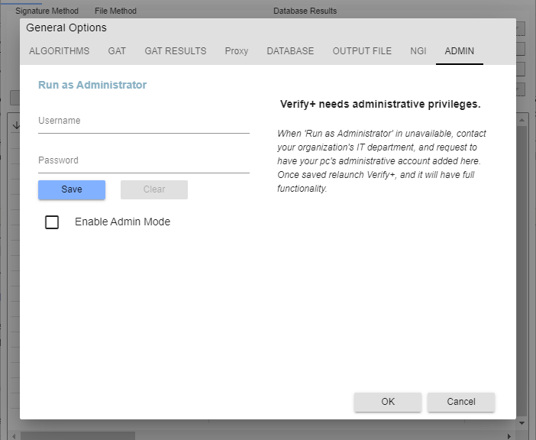

- Upload Calculated Signatures (IRIS)
  - Users have the option to upload signatures to IRIS.
  - The user is first presented with a login prompt
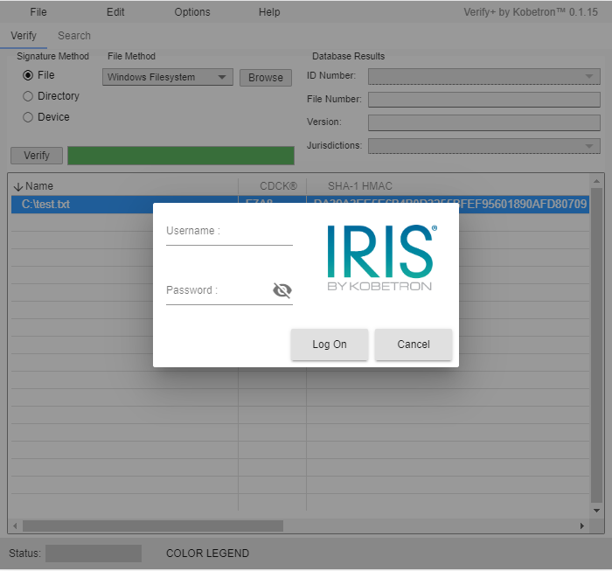

  - Then the user can choose a property, EGM, and component to associate the signature(s) to.
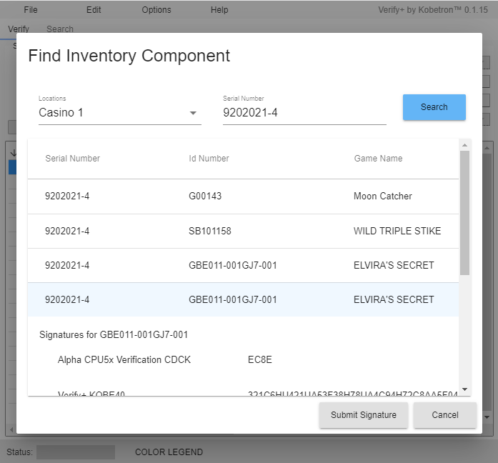

- Show XOR Signatures
  - If the user selects multiple rows of generated signatures, then the Show XOR Signatures option can be used from the Edit or right-click context menus.
  - This feature XORs the Hex-based algorithms of the selected rows together into a single signature.
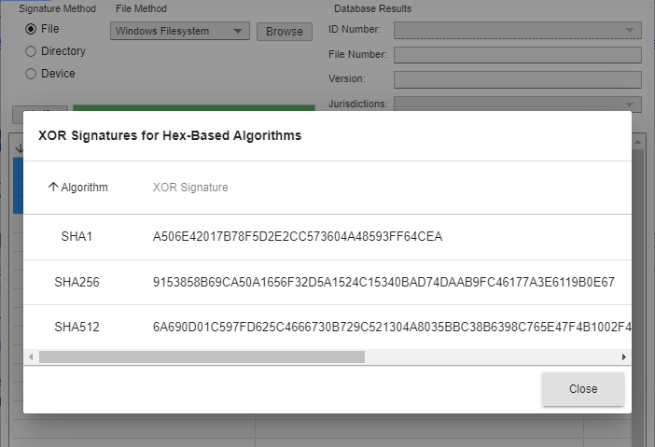

- Added Output file options.
  - GAT and NGI signatures will now also output when auto-output is turned on.
  - Added a GAT Audit Option to output GAT results along with the Machine ID
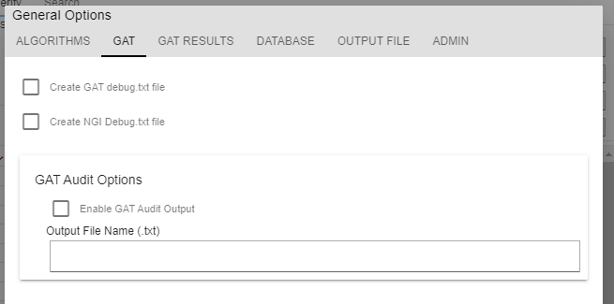

  - An option has been added to the output file to include the device size for the signatured item(s).

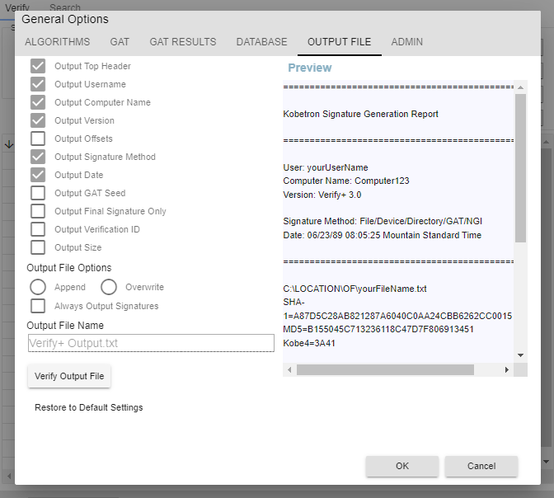

- Added signature text feature
  - An option was added to the Tools menu for Text Signature Tool. This allows the user to type or paste in text and then use the Verify button to generate signatures for all of the enabled algorithms.
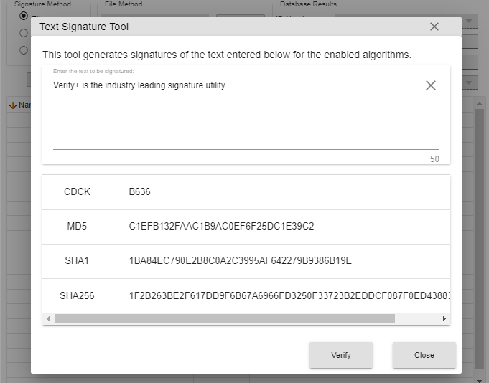

- Added NGI URL Manager
  - When verifying components through NGI, many different URLs could be used by the user to query. The NGI URL Manager allows the user to store NGI Server URLs so they can be easily selected in the future. The "Manage URLs" button is used to bring up the interface to add, edit, or remove stored URLs.
